NAME: P.MANOJ
HT. NO: 2303A52043
ASS.NO : 6.4

1) PROMPT:
Create a Python class named Student with attributes name, roll_number, and marks.
Complete the class by adding:
1. A method to display student details
2. A method to check if the student's marks are above the class average
Use self attributes and if-else conditions.
Assume class average is passed as a parameter.
Also provide a sample usage and output.
Analyze the code for correctness and edge cases before generating final output.
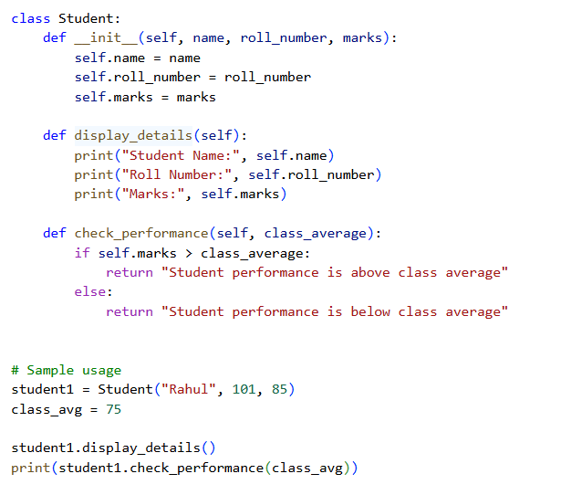
OUTPUT:
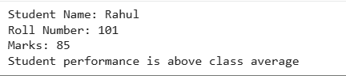
2)
PROMPT:
Write a Python for loop that iterates over a list of integer sensor readings.
Inside the loop:
- Identify even numbers using the modulus operator
- Calculate the square of each even number
- Print the result in a clear, readable format
Use conditional statements and analyze correctness before final output.
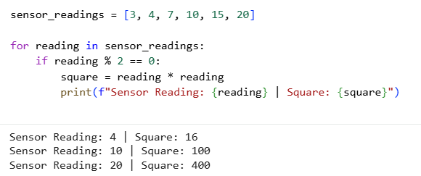
OUTPUT:
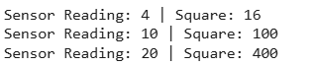
3)
PROMPT:
Create a Python class named BankAccount with attributes account_holder and balance.
Complete the class by adding methods to:
- Deposit money into the account
- Withdraw money from the account
- Prevent withdrawal if balance is insufficient using if-else conditions
Use self attributes and print user-friendly messages.
Analyze the code for correctness and edge cases before generating final output.
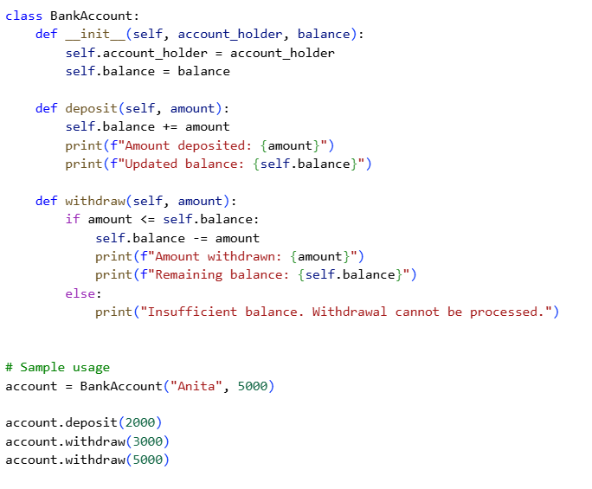
OUTPUT:
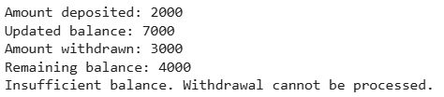
4)
PROMPT:
Given a list of dictionaries where each dictionary represents a student with
name and score, generate a while loop that:
- Iterates through the list using an index
- Checks if the student's score is greater than 75
- Prints the names of eligible students in a clean format
Ensure correct index handling and conditional checks.
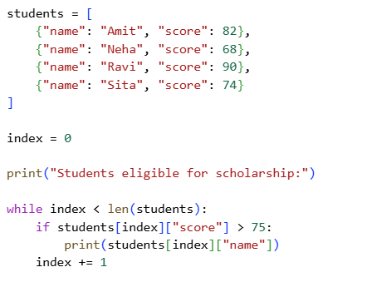
OUTPUT:
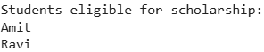

5)
PROMPT:
Create a Python class named ShoppingCart with an empty list to store items.
Each item should have name, price, and quantity.
Generate methods to:
- Add items to the cart
- Remove items from the cart
- Calculate total bill using a loop
- Apply a discount if total exceeds a certain amount
Use loops, if-else conditions, and self attributes.
Analyze for correctness before producing final output.
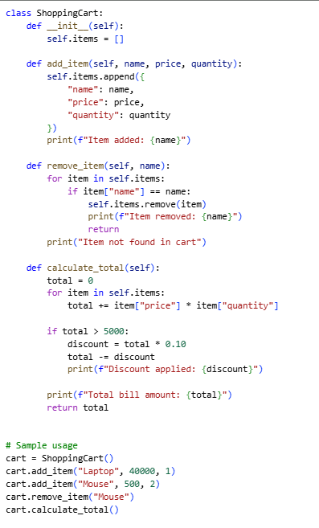
OUTPUT:
